The items listed below are available for purchase. Items will be removed when sold.
Item Description / Link | Sell Price | Pictures
Haunted Living 36-in Freestanding Lighted Skull Figurine Sculpture (Originally $99) - Link | $50 | 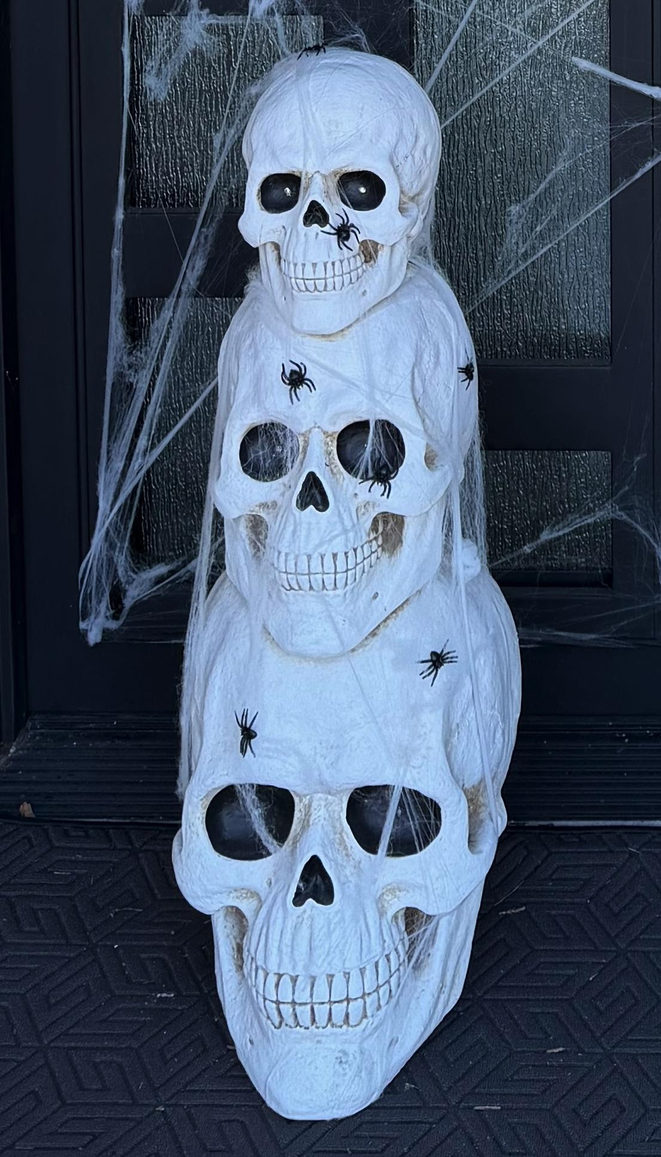
12 Skulls | $10 | 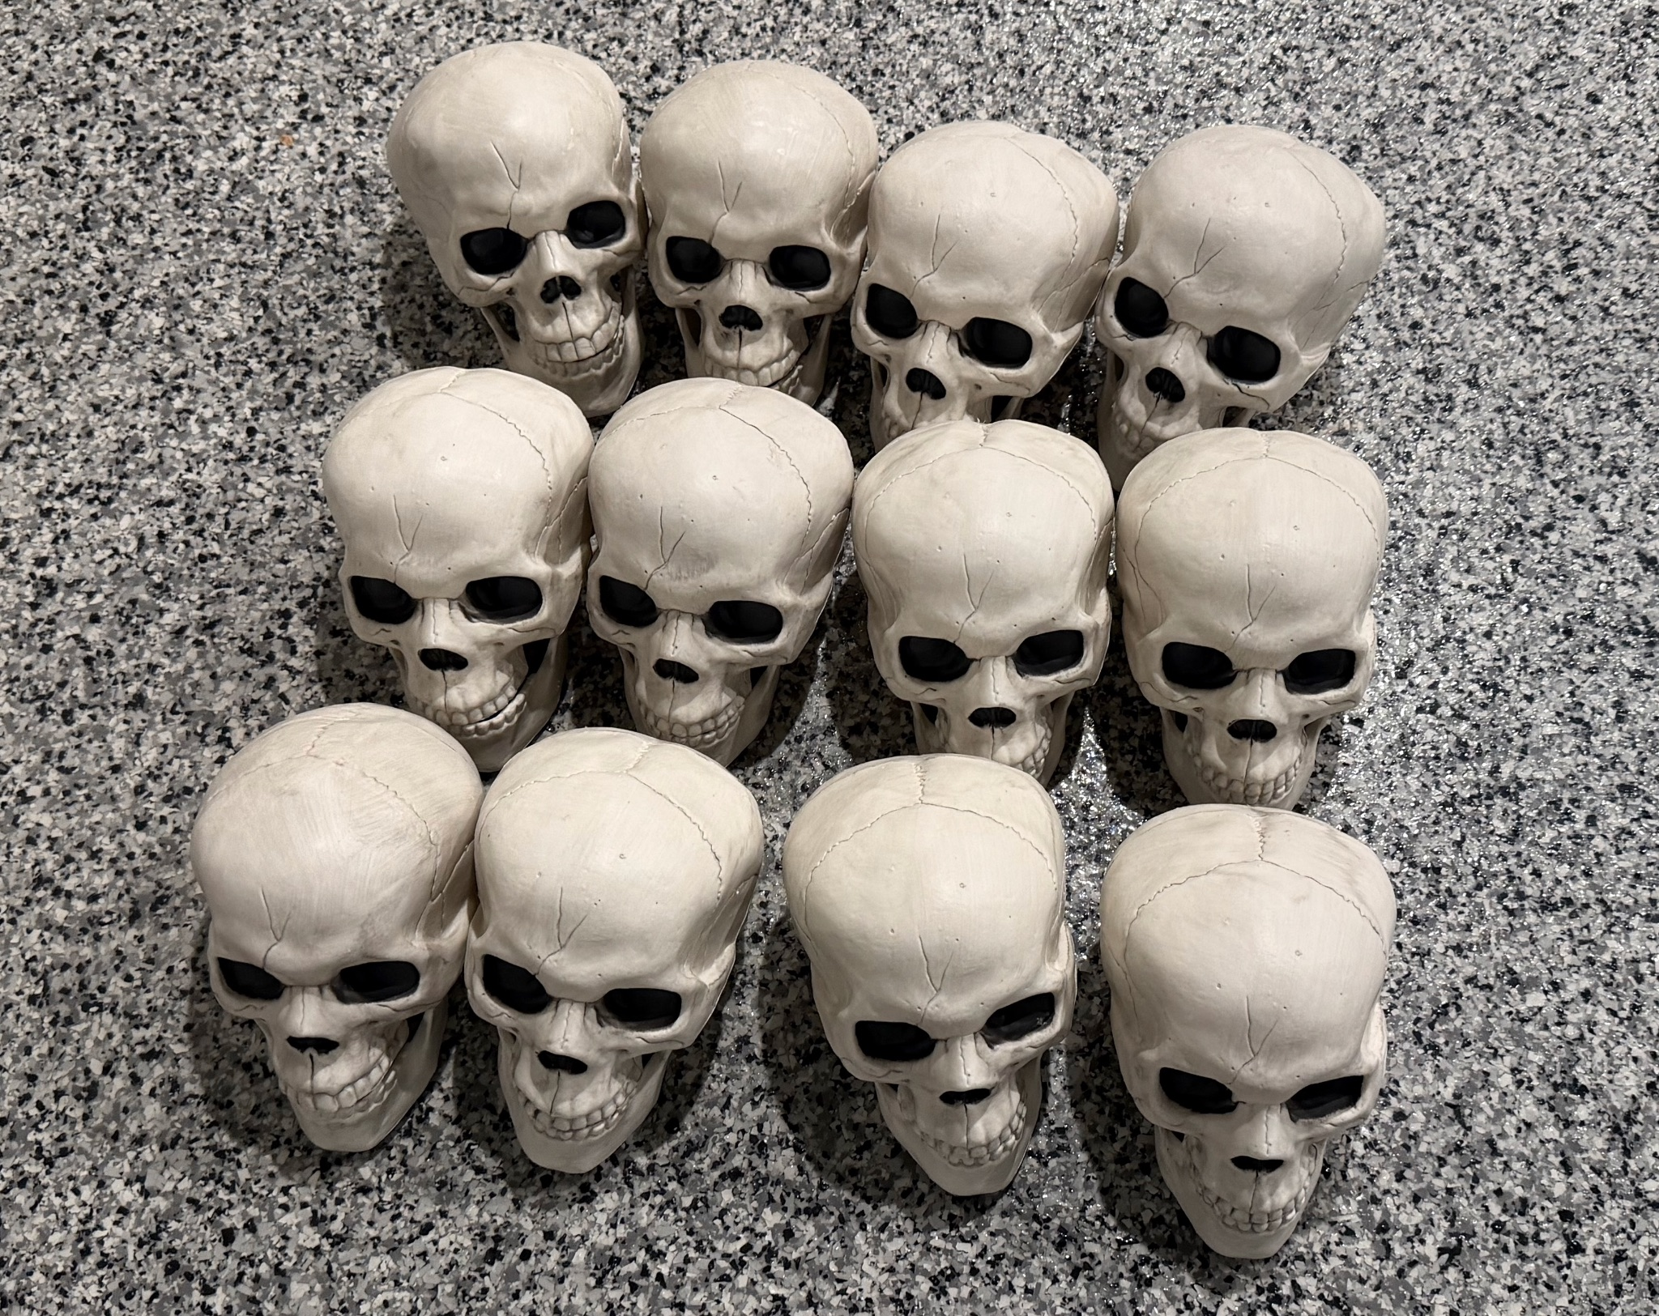
National Tree Company 10 ft Unlit Kingswood Fir Slim Artificial Christmas Tree, 1,715 Tips, Includes Stand, Green (Originally $150) - Link  Christmas Tree Storage Bag - Extra Large Tree Rolling Storage Bag - Fits Up to 9 ft Artificial Disassembled Trees, Durable Handles for Easy Carrying & Transport - Tear-Proof Oxford Duffle Bag(Blue) (Originally $40) - Link | $100 | 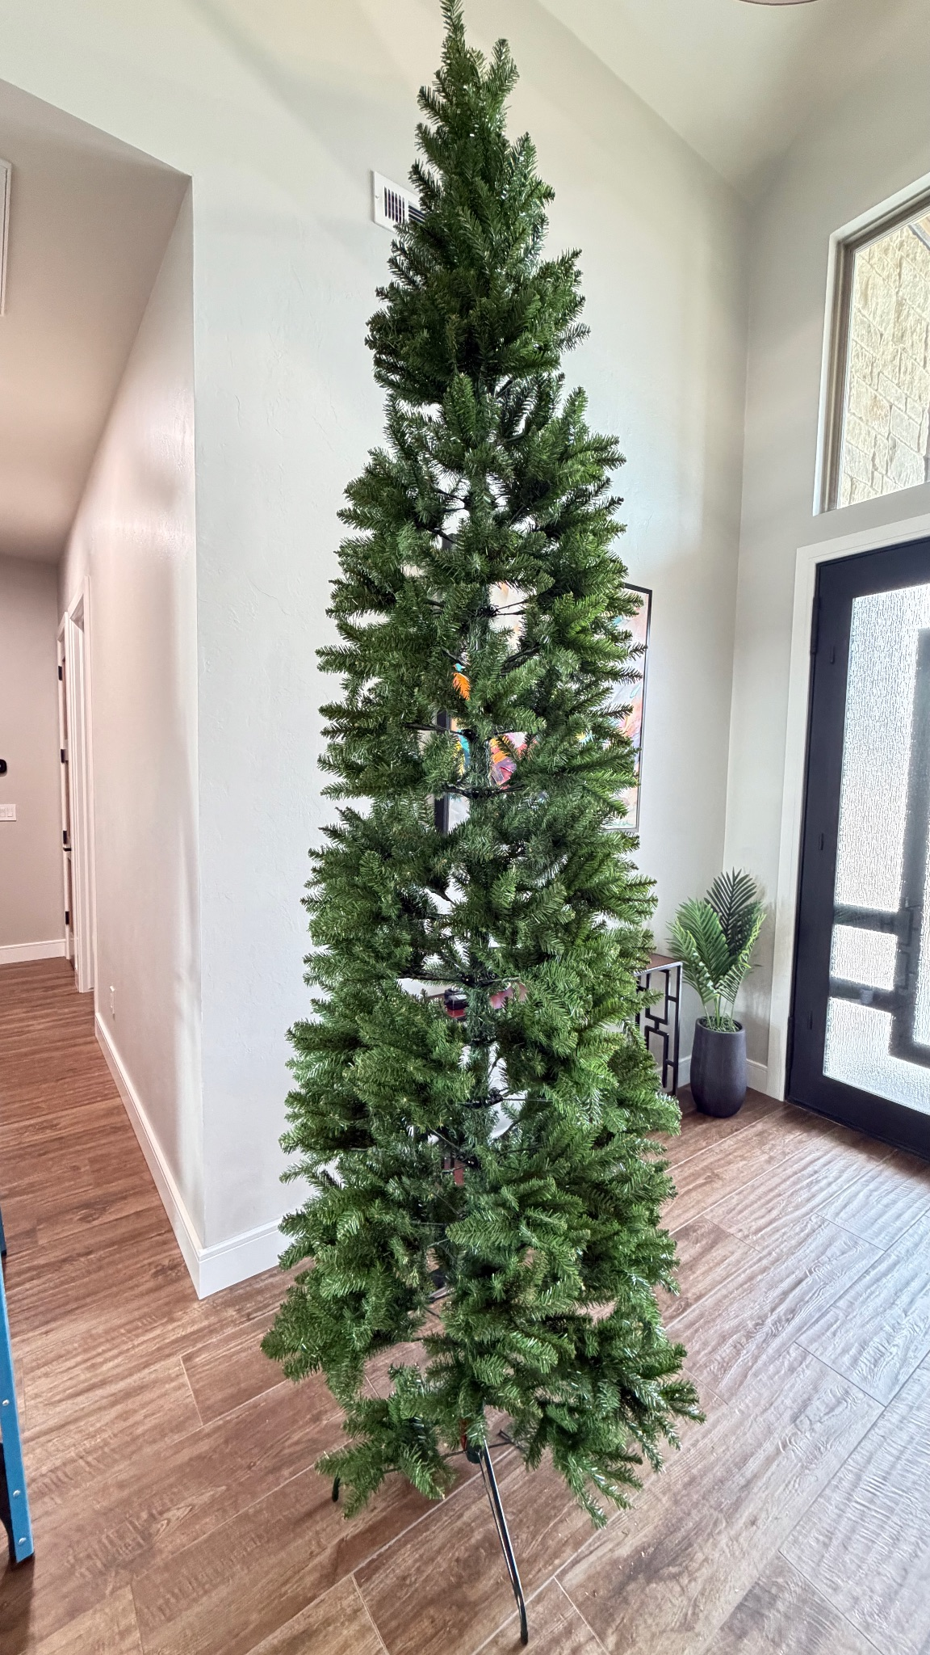  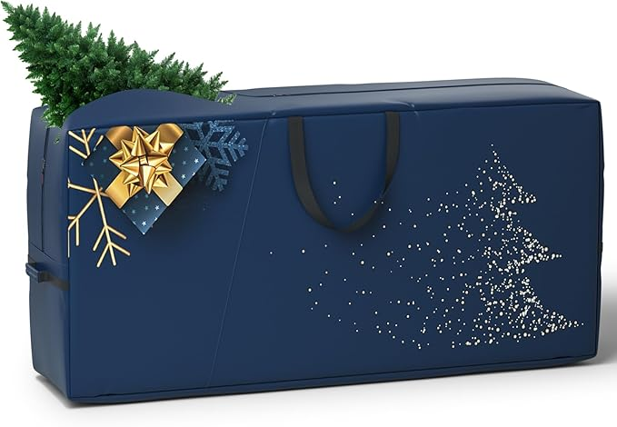
74” LED Snowman Outdoor Christmas decor (Originally $365) | $75 | 